Save Your Analysis to Multiple Excel Worksheets
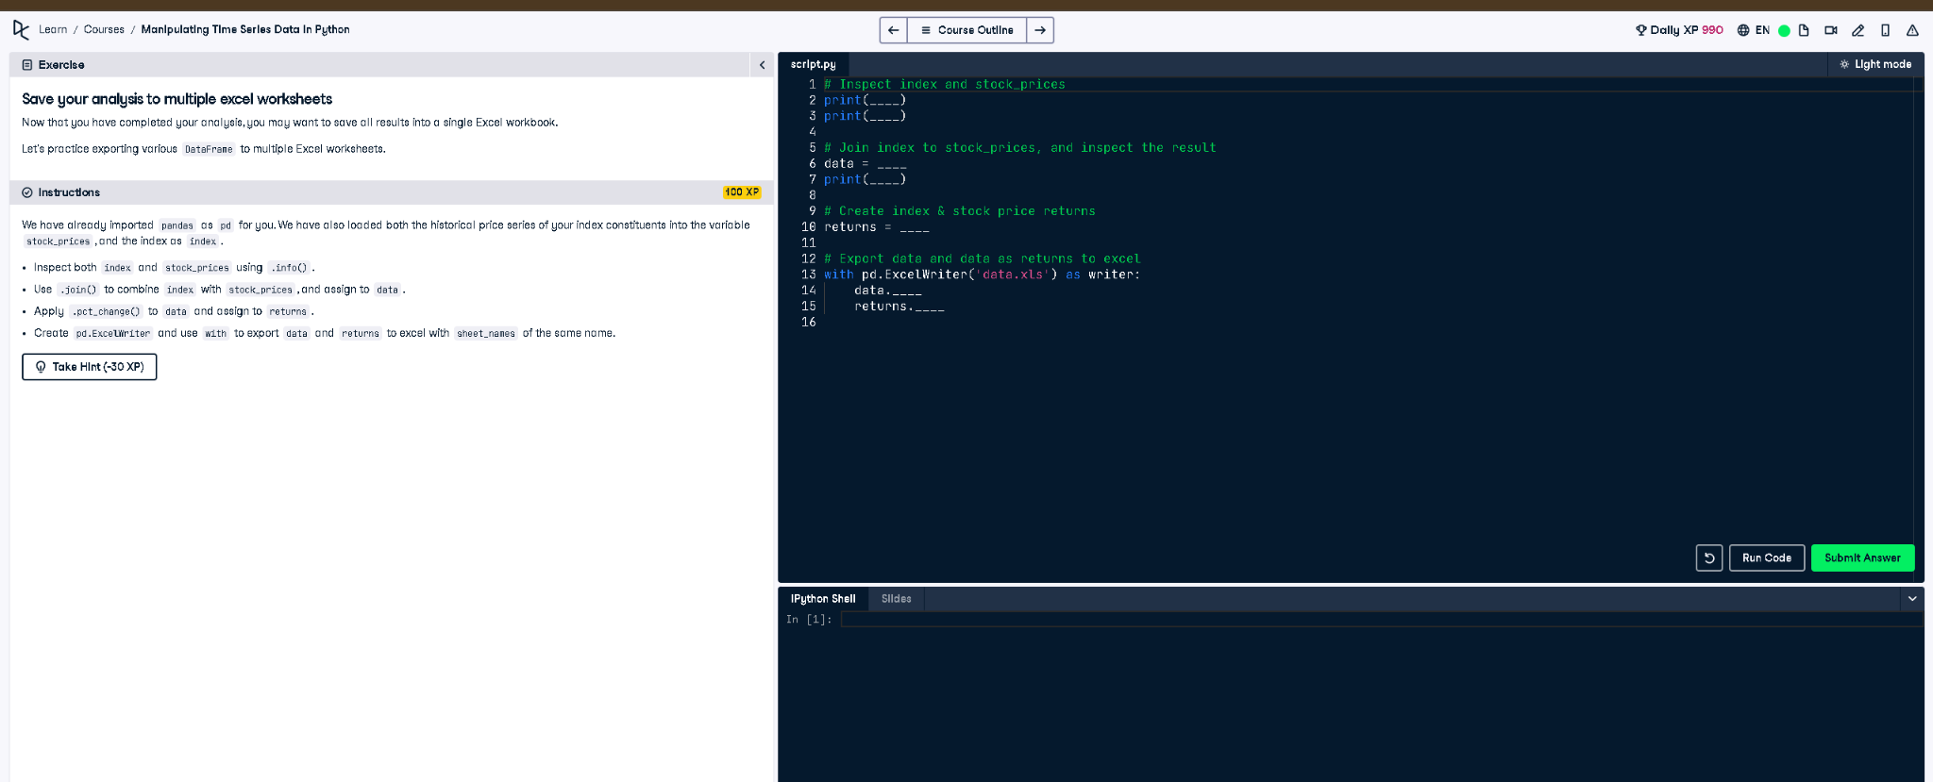

✅ Full Correct Answer:
# Inspect index and stock_prices
print(index.info())
print(stock_prices.info())
# Join index to stock_prices, and inspect the result
data = index.join(stock_prices)
print(data.info())
# Create index & stock price returns
returns = data.pct_change()
# Export data and returns to Excel
with pd.ExcelWriter('data.xls') as writer:
data.to_excel(writer, sheet_name='data')
returns.to_excel(writer, sheet_name='returns')

🧾 Explanation (Simple Words):
You start by checking the structure of index and stock_prices. Then, you join them into one DataFrame. You compute daily returns using pct_change() and export both the original and calculated data to Excel. Each is saved in a separate sheet using pandas' ExcelWriter.

